**Users Documentation**

## Search Patient

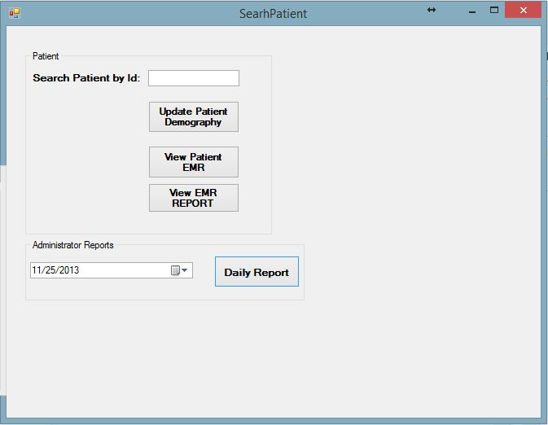

* User can search patient by patient Id and perform the functions like Update patient, View Patient EMR and View EMR Report.
* If patient do not exists user will get Dialogue box will pop up to inform that requested patient does not exist
* if patient exists in the System, Users can perform Various functions from this User Interface.

## View and Update Patient Demography

### a. View Patient Demography

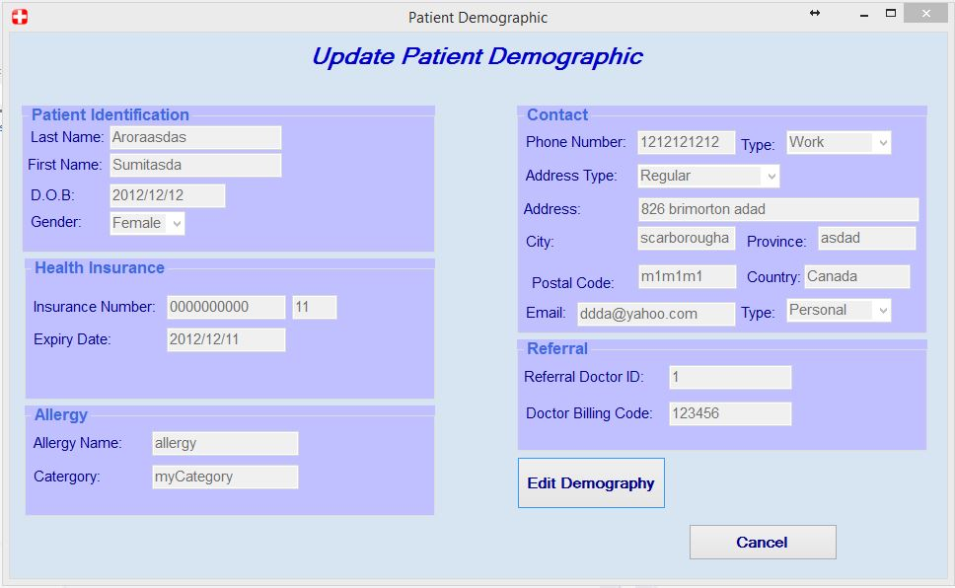

* On clicking Update patient button user will get this User Interface which shows all the patient demography information.
* On clicking Edit Demography button user will see the below image.

### b. Update Patient Demography

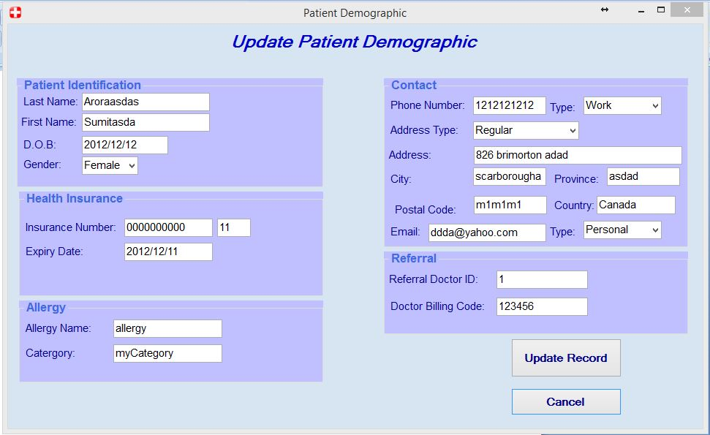

* Users can update the patient Information and click Update Button to Update it to the system.
* Users can press cancel button to close this User Interface screen.

## View Patient EMR

Users can see Patient Information on the top of the User Interface Screen.

### View Patient Radiology

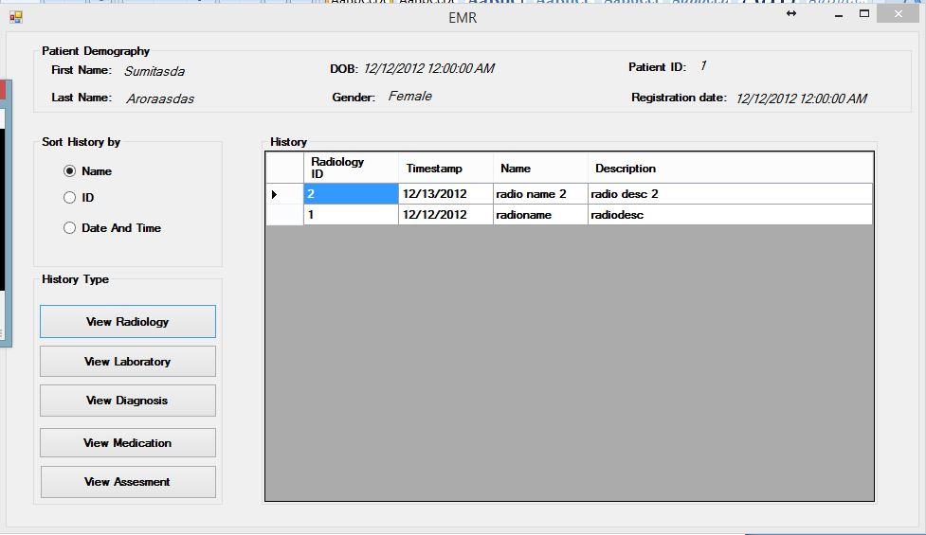

* By clicking View Radiology button, Users can see Radiology order history of the patient and can sort them according to Name , ID or Order Date and Time.
* The history details include Radiology ID, Time Stamp, Name and Description of that particular Radiology order.

### View Patient Laboratory

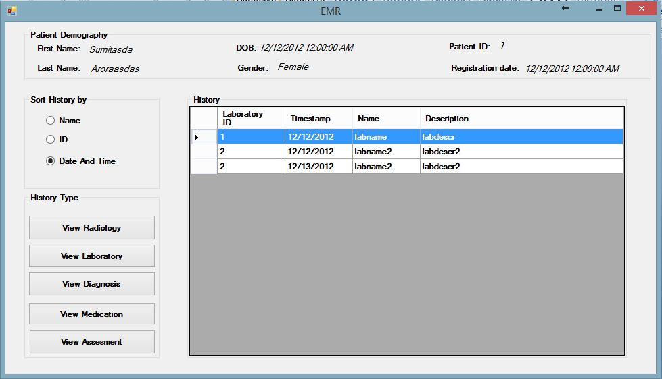

* By clicking View Laboratory button, Users can see Laboratory order history of the patient and can sort them according to Name , ID or Order Date and Time.
* The history details include Laboratory ID, Time Stamp, Name and Description of that particular Laboratory order.

### View Diagnosis

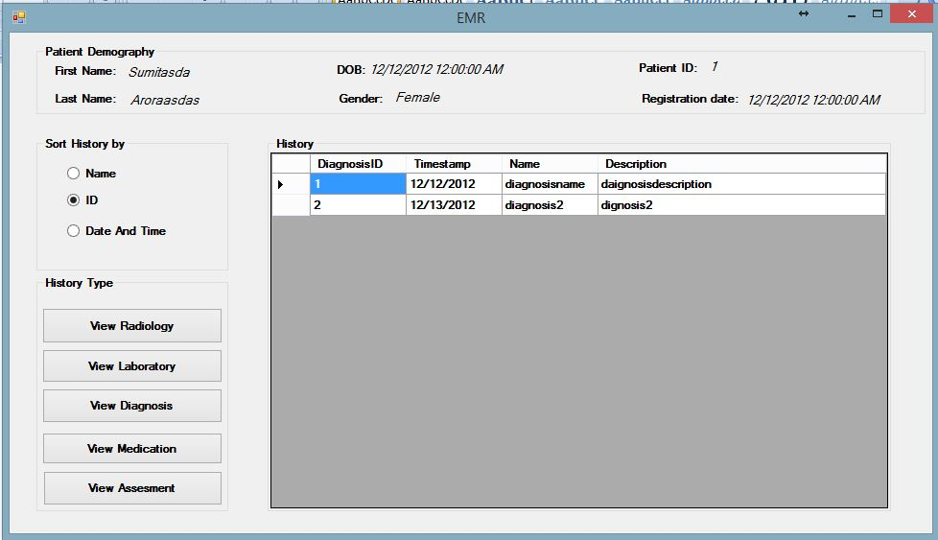

* By clicking View Diagnosis button, Users can see Diagnosis order history of the patient and can sort them according to Name , ID or Order Date and Time.
* The history details include Diagnosis ID, Time Stamp, Name and Description of that particular Diagnosis order.

### View Medication

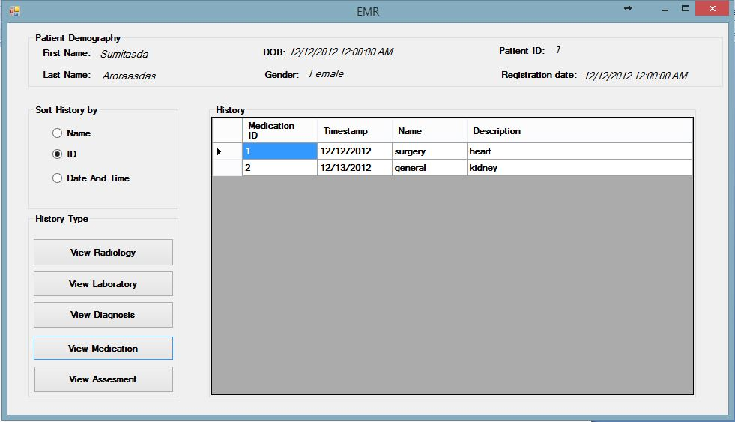

* By clicking View Medication button, Users can see Medication order history of the patient and can sort them according to Name , ID or Order Date and Time.
* The history details include Medication ID, Time Stamp, Name and Description of that particular Medication order.

## View Patient Assessment

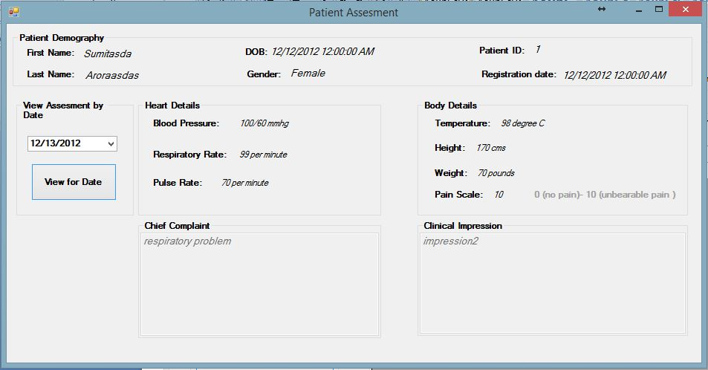

* Users can see Patient Information on the top of the User Interface Screen like Name, Dob, Patient Id, Gender and Registration Date.
* Users can select assessment for particular date selecting date from the drop down list and click view for Date to view assessment for selected date.

## View or Print Patient EMR Report

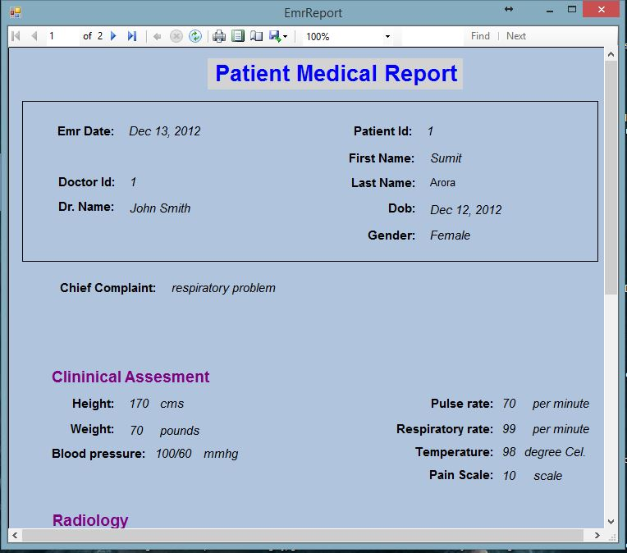

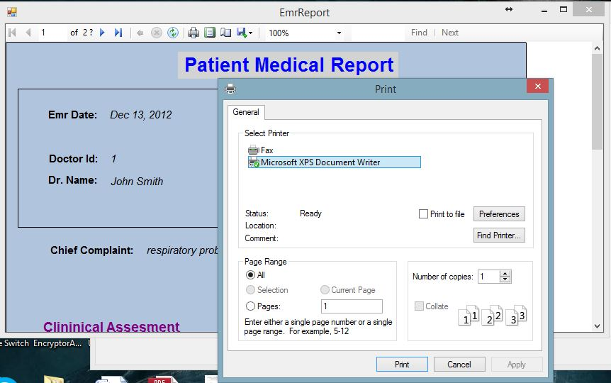

* Users can View Patient Medical Report.
* Users can perform zoom in and zoom out functions on the report.
* Users can go to Next page or enter page number to go to that page number.
* Users can refresh report.
* Users can find word or sentence in the report.
* Users can export the report to various format like pdf, word or excel format.
* Users can set up print page layout and print report.

## View or Print Daily Patient Treated Report

### Select Date from drop down calendar for which user want to generate Daily

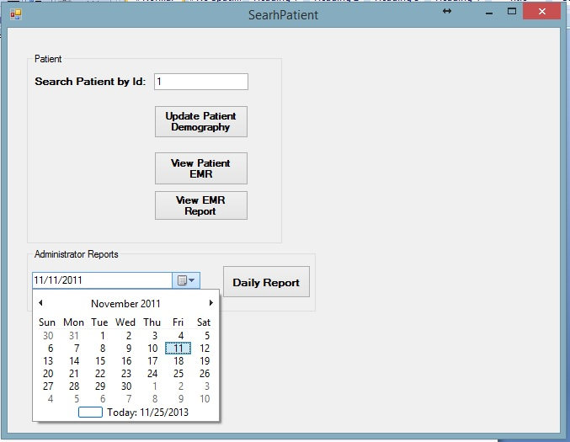

### View and Print Daily Report

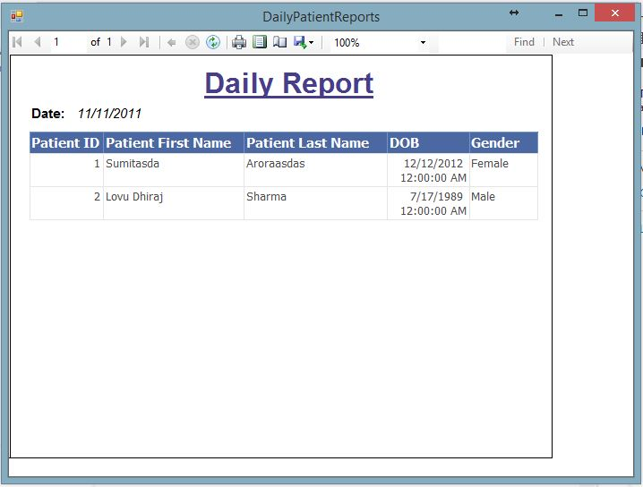

* Users can see Information of patients treated on particular date. The information like Patient Id , First Name, Last Name , Dob, Gender can be seen for individual patient seen by doctor.
* Users can View Daily Report.
* Users can perform zoom in and zoom out functions on the report.
* Users can go to Next page or enter page number to go to that page number.
* Users can refresh report.
* Users can find word or sentence in the report.
* Users can export the report to various format like pdf, word or excel format.
* Users can set up print page layout and print report.